Quantum Computing for absolute beginners
The article is intended for people with absolutely no background in computer science or for people interested to understand what exactly a quantum computer is.
Before we exactly define what a quantum computer is let's understand a few concepts in physics namely- superposition, interference and entanglement.
Now, all matter is made of atoms which comprise of electrons, protons and neutrons. Electrons carry a negative charge, protons carry a positive charge and neutrons carry no charge at all. The inside of atom as hypothesized by physicists is something like the solar system, there's a kernel comprising of neutrons and protons and several electrons that revolve around the kernel in orbits with a certain orbital velocity. The laws of physics say that there is no way to calculate the certain position and velocity of an electron deterministically.
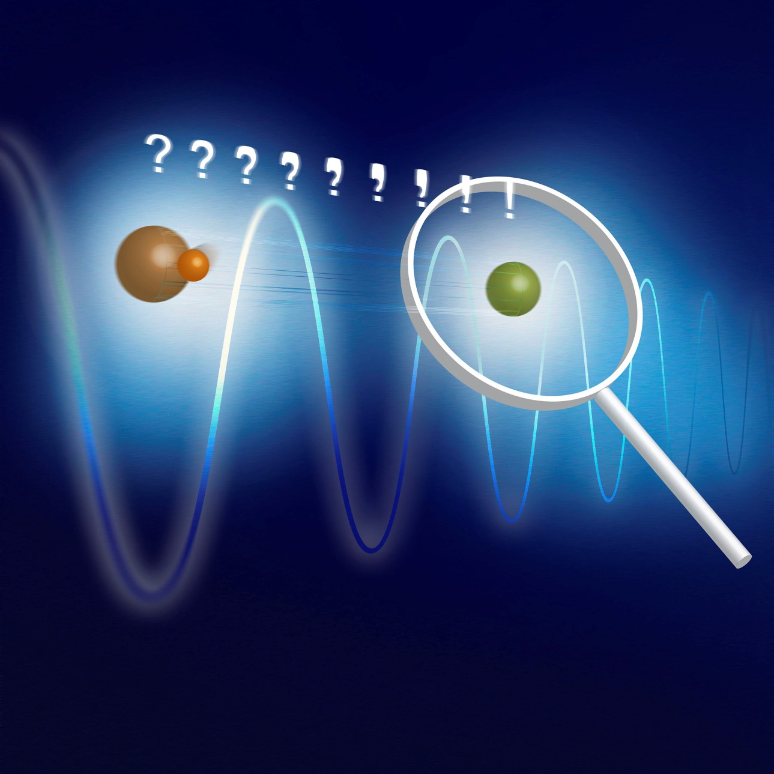

We all have seen that before a cricket match , the teams are told to toss a coin. Teams predict the outcome out of a binary output set of head or tail and the team which correctly predicts the output is said to win the toss.
Now let's say that instead of predicting the final output on the coin, we tell the teams to predict the output while the coin is in air. As in, what does the coin show when it is mid air? Surely there's no definite answer to this. The coin could be almost a head or very close to a tail but not either of them. So the state of the coin can be represented as a combination of heads and tails for example- half a head and half a tail or 3/4th of a head and a quarter tail.
Let's consider another example to this. You're traveling in a train from Delhi to Mumbai. At any given point during the journey your position is a linear combination between your position from Delhi to Mumbai for example- 30% away from Delhi and 70% away from Munbai.
Or let's say you get your exam score. What is your position in the class of 50 can be represented as "12th from the top and 39th from the bottom".
A way to represent your position as a combination of two states is known as your superposition. Now electrons can rotate in an up state (let's say clockwise) or down state (counterclockwise). In a classical computer we represent this up state with 1 and down state with 0. The output set hence contains 2 digits and is called a binary digit or a bit.
In a quantum computer we consider the states of an electrons where it can be halfway into clockwise and halfway anticlockwise which means a superposition of the up state and the down state which can be anything from 0 to 1. So a quantum bit (also known as qbit) can be 0.2 up and 0.8 down.
With a given precision, there are infinite configurations (or pairs of up and down) in an electron which can store infinite amount of data in one bit. (Theoretically) but since electrons keep rotating this data doesn't live for long enough and as there is an uncertainty associated with the position and rotation, the information can be wrong as well.
So in order to have a machine which harnesses the power of quantum bits, we need to have a lot of correct quantum bits for reference (like race track milestones).
Quantum bits do not interact with each other like normal electrons. You see, like charges repel and unlike charges attract each other. But what if I say that charge is superposed (so it is a combination of positive and negative). Long answer short, we entangle these charged bodies with superposed charges so that they are indistinguishable with each other.
What this intuitively looks like is, let's say an animal dies and fossilizes into a little sandstone on your favorite beach. Now if I give you the sandstone it would be very difficult for you to understand whether a part of the stone is the dead animal or sand. This is exactly what entanglement looks like.
Entanglement between to quantum bits is called quantum entanglement.
Story time- my mother used to tell me to sit with the best students of my class. According to her, we'd form an intelligent company together. (Mothers always think their sons are intelligent) but no good student wanted to sit with me because they all thought I was stupid and they didn't want to sit with stupid people because that would neutralize their intelligence. So I would sit with people below me in the rank charts. In that way, we did double the stupid work ever and formed a really stupid company.
This equation of
intelligent + intelligent = 2x intelligent
intelligent + stupid = neutral
stupid + stupid = 2x stupid
is called interferance. When the crests of 2 waves intersect they make a larger crest. When troughs intersect, they make a larger trough. (A crest is the positive part of the wave and a trough is the negative part in this discussion). This interaction is pretty c.
When two quantum bits entangle with each other they exhibit interpolation.
Interference between quantum bits is called quantum wave interference.
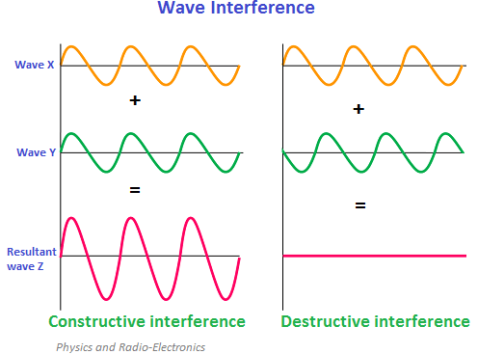
So how does a quantum computer actually look like?
A quantum computer is a huge refrigerator with the temperature as we reach the bottom. At low temperature the quantum Bits exhibit all the above mentioned properties and as the temperature decreases the property becomes more and more obvious.
There are conductors all around them but the particles in action are generally superconductors. The good thing with superconductors that they have a lot of quantum properties.
A quantum computer can process a finite number of quantum bits with a degree of correction (remember that they can loose their state very quickly and show in corrections). In order to model the problems, we need computers with millions of qbits processing. The IBM D'Wave boasts 2000 qBits which is a huge feat because only 2 years ago, 50qBits was a pretty big deal.
Here's a picture of the D'Wave-
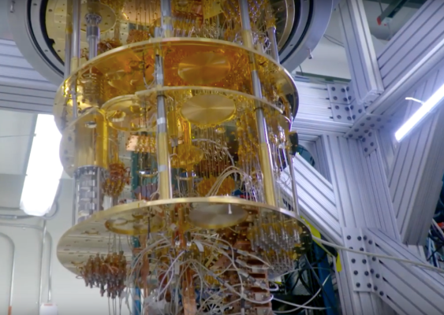
So what problems are these quantum computers used to solve?
Quantum computers are meant to be used in research for problems that are very hard for the classical computers (which have a space constraint that quantum computers don't have) and a limited processing power (quantum computers in turn have a high computing power ).
The problem that comes right off the top of my head is chemical bond modeling for which Qcomputers can be used.
Then we can use them for encryption and decryption or Machine learning problems (Some neural networks take upto 10 days to train) or even physical setting simulation problems.
Right now there is no programming language for quantum computers and researchers and scientists are trying to improve the hardware and software together and come up with a good assembly language for Qcomputers. Once we are done with that and several other layers of abstraction we might have a language like C for QComputers but that will take a lot of time. We need to be ready with our algorithms and solutions in order to catch up with the development that is about to change the world very soon.
How you'd ask? Well. our brain is a quantum machine and with an ideal quantum machine we can perfectly model the brain and maybe even develop a super intelligence of our own.

